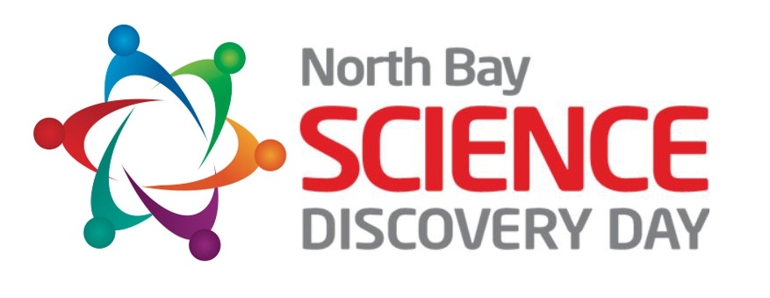
Adapted from the Bay Area Science Festival 2020

How to Help Spread the Word!

The North Bay Science Discovery Day is going virtual March 13, 2021 and remains committed to its original mission: to spark and stimulate young people’s curiosity and excitement for learning science, technology, engineering, and mathematics (STEM). What has been an in-person festival at the Sonoma County Fairgrounds will transition to one day of virtual “events” hosted by North Bay exhibitors (corporations, nonprofits, government agencies, schools, clubs, research institutions, and others). Exhibitors will host 30-60-minute live (synchronous) virtual events on March 13, 2021 – STEM-at-Home, STEM presentations, or explorer tours – to engage 9 to 13 year old young people in deepening their STEM learning. The core values of the North Bay Science Discovery Day remain the same: a non-commercial event that is completely free for youth and families and accessible to a diverse audience. Youth, families, teachers, afterschool educators will be invited to preview and register for events on the NBSDD website.

NBSDD Social Media Channels
Instagram: @northbayscience | Twitter: @DiscoveryDayNB | Facebook: @northbaysciencediscoveryday

Social Media Suggested Hashtags

NBSDD-Specific | STEM/Science
#ScienceTogether  #NBSDD2021 | #STEM  #StemEducation  #STEMGirls  #STEMforKids  #science  #STEAMkids | #ScienceEducation  #COVID19 (Twitter - as applicable)  #Covid_19 (Instagram - as applicable)

Sample Social Media Posts
Please feel free to use and modify these sample posts and tweets as well as craft your own using the guidance provided above.

General - Instagram
- Save the date: Don’t miss the first-ever virtual North Bay Science Discovery Day (3/13/2021) with science experiences you can enjoy from home! #ScienceTogether #NBSDD2021
- Join us in celebrating @northbayscience (3/13/2021). Unique science experiences you can enjoy from home! #ScienceTogether #NBSDD2021
- Let’s discover science together - virtually! Join us for [Event Name, Date]—our contribution to @northbayscience. #ScienceTogether #NBSDD2021
Link: https://www.northbayscience.org/ or your event listing [Add to your bio or link in a story]
Images: An image of your past involvement or activity or the NBSDD Logo.
Accounts to tag on Instagram: @northbayscience

General - Twitter
- Save the date: Discover the wonder of science with us @DiscoveryDayNB, featuring VIRTUAL science experiences you can enjoy from anywhere! (3/13/2021). #ScienceTogether #NBSDD2021 https://www.northbayscience.org/
- Join us in celebrating @DiscoveryDayNB (3/13/2021), with unique science experiences you can enjoy from home. #ScienceTogether #NBSDD2021 https://www.northbayscience.org/
- Let’s discover science together - virtually! Join us for [Event Name, Date]—our contribution to @DiscoveryDayNB (10/21–10/25). #ScienceTogether #NBSDD2021
Link: https://www.northbayscience.org/ or your event listing.
Images: An image of your past involvement or activity or the NBSDD Logo.
Accounts to tag on Twitter: @DiscoveryDayNB

General - Facebook
- Save the date: Don’t miss the first-ever virtual North Bay Science Discovery Day (3/13/2021) with science experiences you can enjoy from home!
- Help us celebrate the North Bay Science Discovery Day (3/13/2021). Engage with unique science experiences you can enjoy from home!
- Let’s discover science together - virtually! Join us for [Event Name, Date]—our contribution to the North Bay Science Discovery Day!
Link: https://www.northbayscience.org/ or your event listing [Add to your bio or link in a story]
Images: An image of your past involvement or activity or the NBSDD Logo.

Issue / Audience-Specific Social
Distance-Learning
- Struggling with learning from home? Us too! Rediscover the wonder of science with your family at the VIRTUAL North Bay Science Discovery Day, March 13, 2021. #ScienceTogether #NBSDD2021
- Energize your STEM distance-learning with activities like [insert event/activity] at this year’s @northbaysciencediscoveryday, March 13, 2021. #ScienceTogether #NBSDD2021
Link: https://www.northbayscience.org/ or event listing. [Add to your bio or link in a story]
Images: An image of your past involvement or activity or the NBSDD Logo.

Teen-Specific
- Want to learn how to code, or discuss women in STEM with other awesome, inspiring teens? Join us at this year’s VIRTUAL North Bay Science Discovery Day. #ScienceTogether #NBSDD2021
- Organized by teens, for teens. Connect with peers that are as passionate about STEM as you are at @northbaysciencediscoveryday, Oct 21-25. #ScienceTogether #NBSDD2021
Link: https://www.northbayscience.org/ or event listing. [Add to your bio or link in a story]
Images: An image of your past involvement or activity or the NBSDD Logo.

COVID-19
- Feeling overwhelmed by #COVID_19? Let’s come together to discuss solutions and make connections through #STEM at this year’s virtual @northbaysciencediscoveryday!! #ScienceTogether #NBSDD2021
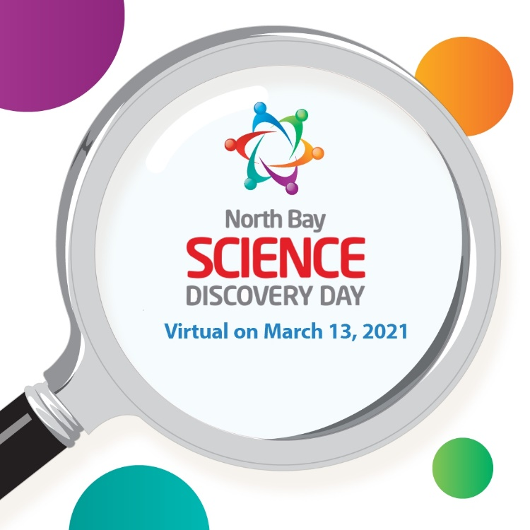

More Ideas on How & Where to Share Your Event
- Your website
- School forums
- Your distance-learning pod
- NextDoor
- Your church mailing list
- Parents or mothers groups
- Download and share flyers with your school or on community forums (TBD)
- Calendar Listings

Sample Copy:

Website Listing:
Let’s discover science together - virtually! Join us for [Event Name, Date]—our contribution to the North Bay Science Discovery Day (March 13, 2021).

Email or Post:

Hi all! The North Bay Science Discovery Day has gone VIRTUAL this year and is just around the corner (March 13, 2021). To celebrate, the North Bay Science Discovery Day is bringing together scientists and educators from around the North Bay to share the joy (and importance!) of science through unique virtual science experiences. Events will feature hands-on activities, behind-the-scenes facilities tours, and stimulating presentations, all of which can be enjoyed from anywhere in the world.

Hope you can attend some sessions and help get the word out. Check out their website for information on participating, as well as a comprehensive schedule. You can also follow the Festival on Instagram (@BayScienceFestival), Facebook (https://www.facebook.com/northbaysciencediscoveryday), and Twitter (@DiscoveryDayNB).

